READING
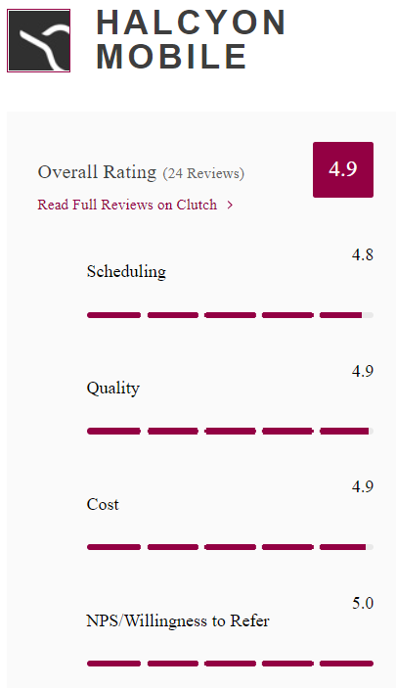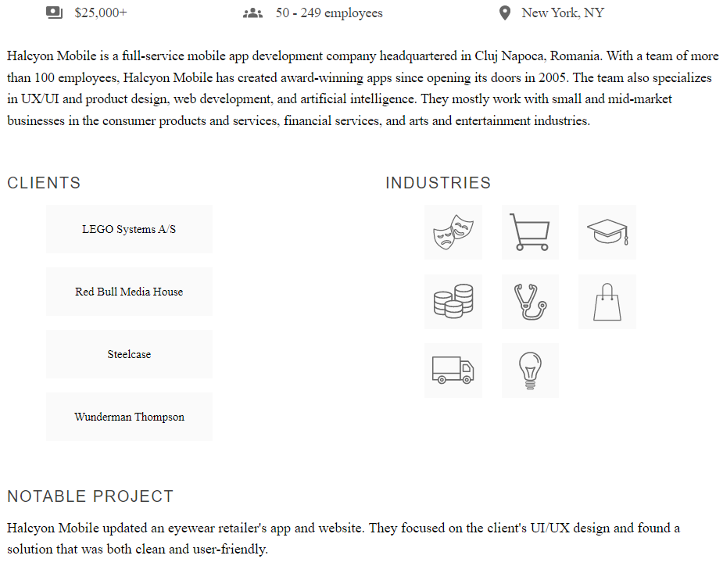
1 - Read the text. Write true (T) or false (F). Justify false answers.

- Halcyon Mobile is based in Romania.
- The company doesn´t have offices in other countries.
- The company is 15-years-old.
- The company has 100 employees approximately.
- The company creates Apps.
- The company works with small and big businesses.
- The company works for various industries.
- The notable project doesn´t provide an effective solution.
- The company´s website is old.
- The company has a low rating.

NUMBERS
2 - Write the telephone numbers.

In numbers
- three five one, double four double six, eight seven nine oh ___________________________
- four two nine, seventy-one thirty-eight, sixty-five forty-three _________________________

In letters
- 0800 5498 1763 ___________________________________________________________
- 249 468 7953 ______________________________________________________________

EMAIL ADDRESSES
3 - Write the following email addresses:

In letters
- Alex_Aziz@jump.jp
_____________________________________________________________________________
- sztulgit-k@bigio.org
_____________________________________________________________________________
In addresses
- capital s c n s, lowercase o f t , at, all lower case scn hyphen soft dot com
_____________________________________________________________________________
- all lowercase info at all lower case v i r o n underscore i t dot com
_____________________________________________________________________________

HAVE GOT
4 - Complete the sentences with HAVE/ HAVEN´T/ HAS / HASN´T.

- Your computer __________________ got a fast processor. (+)
- __________________ these companies got a good software?
- This computer __________________ got an updated anti-virus. (-)
- The offices __________________ got printers. (+)
- __________________ the manager got a modern computer?
- Peter and Laura __________________ got new mobiles. (-)

PRESENT SIMPLE OF TO BE (am, is are …)
5 - Complete with the correct form of the verb TO BE.

- Claire _____________ in the company. (-)
- _____________ Sam at the office today?
- I _____________ from San Francisco. (+)
- The topic _____________ fascinating.(+)
- The documents _____________ in the pendrive. (-)
- _____________ they in a videocall?

PRESENT SIMPLE
6 - Choose the correct option.

- Jack and I develop / develops clients´ website.
- Does Sam take / Sam takes time to implement new platforms?
- He doesn´t does / do research on new technologies.
- Laura and Peter collaborates / collaborate with content creators.
- Does she reviews / review their day´s work in the afternoon?
- They don´t / doesn´t attend meetings to discuss projects.

PRESENT SIMPLE

7 - Complete the text with the correct form of the verbs in brackets.
Tricia ´s Routine
Tricia is a developer. She 1 ___________________ (prepare) for the day. She 2 ___________________ (drive) to work. Then, she 3 ___________________ (check) emails for the first time of the day. She 4 ___________________ (get) back to any urgent requests and she also 5 ___________________ (organize) daily tasks. She 6 ___________________ (discuss) her ideas with her boss.

WRITING
8 - Look at the table about Soft Labs. Write a description of the company.

Company Name | Soft Labs
Business | a web and mobile app development company
Head office | Los Angeles, USA
Branch offices | 0 (zero)
Staff | 50 employees
Activities | provide product strategy, UX/UI design and IoT development services
Some Clients | World Health Organization, World Wildlife Fund, USC, UCLA
Present Project | design and develop a mobile app for a sports stock market
Website | https://softlabs.com/

Start like this:
Soft Labs is a web and mobile app development company. The head office is based in Los Angeles. It doesn´t have branch offices. The company has 50 employees. It provides product strategy, UX/UI design and IoT development services. The clients are World Health Organization, World Wildlife Fund, USC and UCLA. The current / present project is to design and develop a mobile app for a sports stock market./ The company designs and develops a mobile app for a sports stock market. The website is softlabs.com.
________________________________________________________________________________

